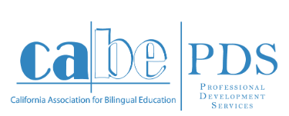
Professional Development Institute Proposal
We welcome your ideas on professional development topics that are current and relevant to the education of English Learners and linked to CABE’s vision of biliteracy, educational equity, and 21st century success for all.
Please complete all fields and email to: kris@gocabe.org
Name: |  |  |  |  | Date:
Phone: |  |  |  |  | Email:
Topic: |  |  |  |  | Target audience: | Elementary teachers: Primary (TK-3) Upper (4-6)  Secondary teachers: Middle (6-8) High (9-12)  Administrators: Elementary Secondary District
Qualifications for presenter:
Description of the institute content:

Link(s) to the CABE vision:
(biliteracy, educational equity, and 21st century success for all)
Link(s) to and aligned with California state content standards:
(CCSS ELA, CCSS math, CCSS Standards for Literacy in History/Social Studies, Science, and Technical Subjects, NGSS standards, and/or the history/social science content standards)
Specific link(s) to Integrated and/or Designated ELD:
(based on the CA ELA/ELD Curriculum Framework)

Link(s) to the research on the topic:

Link(s) to the new definition of professional development:
(sustained, intensive, collaborative, job-embedded, data-driven, classroom-focused)
How will this institute impact the academic instruction and language acquisition support that English Learners receive in the classroom?

