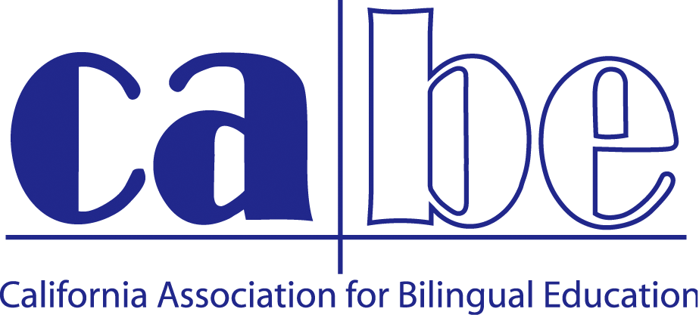
CEO REPORT TO THE BOARD OF DIRECTORS
ALIGNED TO THE STRATEGIC PLAN
SUBMITTED BY JAN GUSTAFSON COREA
February 24-March 31, 2014

NEW DEVELOPMENT
• 4.1 Multilingual Excellence
- Attended the Californians Together meeting and contributed to the planning and
discussion on the new campaign for the California Campaign for Biliteracy
- Reviewed applications for the Multiple Pathways to Biliteracy – District Recognition Award
- Coordinated elements of the Seal of Biliteracy Reception—flyer, email blasts,
certificates, reception plans, special guests (Torlakson and Gil)
- Supported the work for 2Way CABE Affiliate
- Planned and organized dual language immersion discussion group with Ginger
Collier and Wayne Thomas at CABE with DLeNM, ATDLE, Cal Tog, and 2-Way CABE
- Shared the CABE Vision of Biliteracy, Educational Equity and 21st Century Success in a variety of meetings.
- Continued the Bilingual and Proud of It campaign with t-shirts and pencils to sell
at CABE store.
- CABE 2014 preparation with staff, board, and partners—program, speakers, Multilingual Educator, special events,

• 4.2 Data Dashboard – Phase 1 Content Development
- Subcommittee met to discuss content

• 2.3 Design for Success Website – Content Development
- Worked with Norma Rocha on the content and design of our webpage
- Provided several pieces of information on the CABE Facebook page
- Office upgrade of wireless network
- CABE 2014 website updated, design elements

STRENGTHEN & EXPAND

• 2.2 Professional Development
- Attended the Monterey Regional Conference in February
- Supported the selection of workshops and presenters for the regional and annual conference.
- Supported the planning and organization of the annual conference (sponsors, speakers, special guests, program information, board roles, contracts, promotion and marketing, program coordination, program editing, board assignments, Multilingual Educator, contracts, planning committee, honorary chairs, co-chairs, memorials, awards, signage, registration company, registration monitoring, close communication with staff, etc!)
- Maintained regular contact with Elizabeth Jimenez of CABE PDS on the trainings and services she is providing—Monterey, Yolo, LA, Mc Farland, Anaheim, San Bernardino, and Folsom Cordova.
- Worked with Elizabeth on CABE Back to School Series.
- Attended Anaheim City SD dual language parent night and facilited small group as part of PDS contract
- Attended and spoke at the Region I Reception the night prior to the Sacramento Regional Conference.
- Edited and produced the Multilingual Educator
- Made contact with San Diego districts and CABE members regarding CABE 2015

• 3.1 Family and Community Engagement
- Supported the P2I team in their implementation of the I3 grant and the various contracts we have.
- Held phone meetings with partners from CSU East Bay and Mission Promise Neighborhood (SF) to discuss evaluation, program implementation and recruitment.
- Supported CABE’s participation in DELAC trainings via P2I facilitators (collaboration with Cal Tog and CRLA)
- Held call with CDE to debrief on our contract work with SPAC (facilitated by Carlos Maya) and to prepare for the Migrant Education Conference.
- Supported CDE Migrant Education Conference by sending P2I staff to present and table at the conference.
- Met with Pasadena USD and P2I team members Maria Villa and Toni Hernandez on ongoing and upcoming contracts through their Magnet Schools Grant
- Had CABE representative (Liz Jimenez) attend and present at Families in Schools parent formum.

• 4.6 Fund Development
- Recruited sponsors for CABE 2014—we have reached $92,500 in sponsorships
- Prepared for mid year meeting with grant officers from Sobrato.
- Worked with staff to generate marketing ideas and plans for CABE 2014
- Worked with accounting consultants to develop a stronger, more transparent budget.
- Reviewed i3 Annual Program Review (prepared by Maria Quezada and Wexford)
- Generated $4000 for CABE and $4000 for 2Way CABE through our Pre-Conference Institute at NABE
- Received $5000 donation from Sandra Anderson to support the beginning of the ABLE Fund-- Advancing Biliteracy Leadership in Education.
- Contracted with Sherri Martinez on a short-term basis (2 months) to develop the ABLE Fund and submit required paperwork to the California Community Foundation.
- Met with Sandra Anderson, Shelly Spiegel-Coleman, and Sheri Martinez to develop the ABLE Fund strategic plan
- Coordinated with Accounting Consultant Virgilio Viernes to finalize audit, update our account reconciliation to date, correct cost allocations in the budget, and prepare for the transition to FMJ.
- Communicated with all CABE 2014 sponsors
- Met with Barbara Flores and Eddie Velazquez to discuss developing a Superintendent Recruiting Service
MAINTAIN EFFORTS

• 3.4 Advocacy
- Communicated regularly with Martha Zaragoza Diaz and Shelly Spiegel-Coleman
- Communicated with Senator Lara’s office regarding SB 1174
- Maintained contact with NCLR on the nation and state advocacy days
- Provided input on CABE/Cal Tog’s Biliteracy legislation (AB2303)

• 3.3 Partnerships
- Confucius Institute—confirmed that they are attending CABE 2014, sending paid participants as a partner, and including a greeting in the CABE 2014 program
- PTA—confirmed that they are attending CABE 2014 as a partner
- Velazquez Press—confirmed the various aspects of their sponsorship
- NABE---emailed president Santiago Wood on a variety of occasions, addressed the conflict in conference dates for 2015
- Californians Together—attended quarterly meeting and worked collaboratively on a variety of projects (Seal of Biliteracy, DELAC LCFF trainings, SB1174 and AB2303, other legislative issues)
- CALSA—confirmed sponsorship of ALS luncheon
- Communicated with CFLP on our upcoming conference dates
- Met with Luis Molina, Mayor of Patterson, along with President Francisca Sánchez
- Attended BCN on March 26
- Met with Bob Barboza and Shelly Spiegel-Coleman

RETHINK/RESTRUCTURE

• 3.5/4.3 Membership/Chapters--pending
• Regional Conferences (Subset of 2.2)—pending

OPERATIONS

- Led organization through the transition of the Business Manager position and signed contract with FMJ
- Developed transition plan with FMJ
- Worked closely with part time consultant Virgilio Viernes, short term Accounting Consultant on our accounting records and system
- Completed audit requirements.
- Maintained close monitoring of the CABE budget
- Met with our Coordinating Council and Staff on a regular basis
- Maintained close communication with staff during intense work periods due to the annual conference, the DELAC trainings, etc.
- Attended Angels/Dodgers baseball game with staff
- Communicated regularly with Board members
- Prepared CABE Board Election materials for dissemination
- Celebrated staff birthdays
- Send weekly staff bulletin and updates
- Hired two temporary staff to support conference preparations
- Will hire 10 temporary staff for the annual conference

